GOVERNMENT MARKETING: SELECTIVE SUPPORT FOR NATIONAL PRODUCERS

Statement of the problem. While agreeing with this famous saying by J.F.Kennedy, we should keep in mind the dichotomic nature of the term “crisis”. On the one hand, it can be viewed as a situation when something that used to function does not appear to be operational or useful anymore. On the other hand, crisis can provide an opportunity to reevaluate the situation at hand and choose the most promising (in terms of efficiency) path of further development.
Recent years of the modern history of Ukraine were widely associated with social, political, and economic instability. Current nation leaders face a set of challenging tasks, such as stabilizing the economic situation, securing the stable development of the country, and making provisions for the civic society establishment, eventually integrating Ukraine into Europe.
The recent period from late 2015 through early 2016 was, however, marked by new challenges for Ukrainian economy. Ukraine was forced to withdraw from the market outlet that accounted for more than 50% of total exports. The outlet in question was the market of the Russian Federation (please refer to fig.1, to table 1).
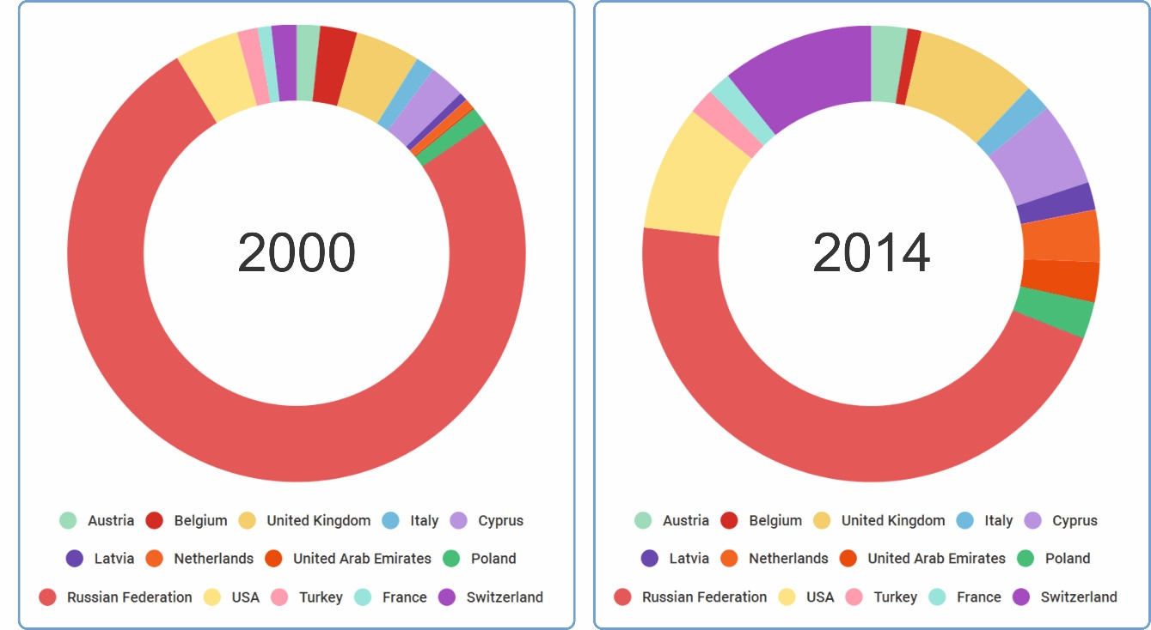
Fig. 1. Ukrainian Export Pattern Dynamics Countrywise (taking into consideration the largest exporters)
Table 1
Ukrainian Export Pattern Dynamics Countrywise
(taking into consideration the largest exporters), %
Country | 2000 | 2005 | 2010 | 2014
Austria | 1,29 | 1,55 | 1,55 | 1,72
Belgium | 2,02 | 2,37 | 2,04 | 0,66
Cyprus | 1,96 | 3,95 | 3,56 | 4,00
France | 0,74 | 0,94 | 1,05 | 1,11
Italy | 1,03 | 1,21 | 1,08 | 1,26
Latvia | 0,46 | 0,65 | 0,27 | 1,32
Netherlands | 0,53 | 1,19 | 0,88 | 2,47
Poland | 0,98 | 1,01 | 0,79 | 1,76
Russian Federation | 58,77 | 41,97 | 43,85 | 30,71
Switzerland | 1,37 | 4,83 | 3,67 | 7,23
Turkey | 1,12 | 1,47 | 1,31 | 1,23
United Arab Emirates | 0,12 | 0,42 | 0,59 | 1,92
United Kingdom | 3,53 | 4,89 | 4,74 | 5,73
USA | 3,52 | 4,59 | 5,08 | 5,97
* As reported by the State Statistics Service of Ukraine

Analysis of recent research and publications. According to the figures provided by the State Statistics Service of Ukraine, the volume of primary goods exported to Russia from Ukraine fell by 57.4%. The official sources state that Ukraine would lose around 600 million dollars as a result of trade embargo.
Evidently, the loss of this market should be compensated by finding alternative outlets. Potentially having the largest export and transit capacity, Ukraine shall accept this challenge and redirect the flow of its external commerce. Therefore, we face a set of critical questions, namely, in what manner the flow of Ukrainian goods shall be redirected, what measures government should take to support domestic producers in their efforts to expand to the foreign markets, and whether the government shall undertake the aforementioned function.
Goals of the article. The aim of this paper is to describe the mechanism of selective support for national producers in the situation of social, political, and economic instability in the country.
The tool that could answer these questions, and realize the strategy of exploring new markets in the circumstances concerned, is government marketing. The necessity of considering marketing philosophy when taking governmental actions was emphasized by Philip Kotler, Peter Grahama, Keith Snavely, and others as early as in XX century.
Despite using the term “government marketing” within the categorical framework for quite some time, it can be said without prejudice that the concept of government marketing is still being developed.
Without engaging into controversy with the authors that defined the “government marketing” using their respective approaches, let us describe our perspective on this notion.
The contest of any complex notion is a synthesis of its components. Let us define the notions “government” and “marketing” keeping in mind the blending principle.
Referring to the Cambridge Advanced Learner’s Dictionary & Thesaurus Dictionary, government is the group of people who officially control a country; the system (or the activities) used for controlling a country, city, or group of people.
The classic definition of marketing by Philip Kotler and Gary Armstrong (2010: p. 5) is "the process by which companies create value for customers and build strong customer relationships in order to capture value from customers in return".
As can be seen from the above, government marketing is a set of government actions aimed at supporting (developing) businesses that operate in the respective country.
In addition, marketing as a branch of science is a knowledge system that provides information relevant to competitive activity on the physical market. However, should the government equally support all domestic producers, the notion of competitive struggle becomes obsolete.
The global market has a tendency towards Liberal Absolute, where the political border between countries become vague and the whole world is viewed as a single market. Therefore, the globalization process proves to be an ivory tower for the government to contribute into marketing activity.
That being said, there are conditions that would render the marketing activities of the government impossible. For instance, the command-and-control economic system would have no benefit from the marketing, since in that case the enterprises have no challenge when it comes to sales, as the state planning system would specify the quantity of goods produced and distribution channels.
Taking into consideration the above, the government marketing, as we see it, is a set of government actions aimed at supporting domestic producers in their efforts to expand to the foreign markets. The competitors in this case are the domestic producers of the country that is subject to such expansion, as well as the producers from the other countries that sell their goods at the market of this country.
In order to provide further insight into the world practices of conducting the state marketing, let us examine the history of various countries in the context of supporting respective domestic producers upon their entries into the global market.
Let us summarize the international experience and name a set of tools used by the government to influence a consumptive demand.
Governmental actions aimed at implementation of marketing activities can be described by means of marketing mix (4Ps model).
The manufacturer offers the product that satisfies the demand to the consumers. In compliance with the product policy, the government provides informational support for exporters, identifying the goods that would meet the demand.
For instance, Australian government announced the program of informational support towards export to Korea, Japan, and China, since the analysts of core-business departments considered this direction being the most prospective for Australian manufacturer. As a part of the program, Australian government shall invest a total of $ 2450000 within two years. These investments include training programs for the owners of small and medium businesses, as well as their employees so that they could better understand export business, access and enter into new commercial pacts with high-profile Asian partners of Australia.
The price is defined by the consumption value of the product, prices offered by the competitors, production costs, and desired revenue level. As a part of its pricing policy, the government effects financing of the manufacturer himself, as well as special purpose financing of the foreign customers for them to acquire goods provided by domestic producers. Customer debt financing in various countries is effected with lower interest rate and on much more beneficial terms than local banks would provide. These measures improve the competitive performance of exported goods.
For instance, if the customer outside Canada purchases equipment, and faces a choice between local manufacturer and Canadian, the Export Development Canada would provide him financial means and extension on much more beneficial terms than his domestic manufacturer. The Export Agency of Denmark would act in a similar manner. Besides that, Danish export credit agency analyzes the macroeconomic situation, making conclusions and predictions. The organization offers comprehensive advices for the exporters, providing relevant updates that describe the market situation, thus influencing the price formation.
Promotion is referred to the company activity aimed at communicating information about the competitive advantages of their products and persuading target customers to buy them. Promotion policy is executed through the government marketing by means of providing financial support to cover marketing expenses. For instance, any Australian exporter can be compensated by 50% of his marketing expenses related to promoting his products in foreign countries for the total amount of up to $ 15 000 annually. Moreover, export agents provide their customers with necessary support by preparing communication campaigns, analyzing information, and getting in contact with marketing agencies in other countries.
Placement includes activities that make the product available for target customers. Placement strategy provides means for determining the most suitable channel for product promotion. Hence, the placement policy in the context of government marketing is evident as a set of comprehensive advices for domestic producers that covers a wide range of problems, including the search for potential sales options. One of the most vital aspects of entering foreign markets and establishing market outlets is connections. In Denmark, the Danish Trade Council under the auspices of the Ministry of Foreign Affairs provides assistance for the exporters so they can establish necessary connections in foreign countries.
We believe that incorporating the aforementioned model of government marketing could help Ukrainian government to reach their goal, namely, to improve the competitive performance of national exporters. Considering the reduction of hard currency proceeds, the causes of which were pointed out at the beginning of this article, it is vital for Ukraine to develop and implement the concept of government marketing.
The specific steps necessary for implementation of government marketing concept in Ukraine should include as follows:
• conducting a Foresight research in order to create a perfect picture and draw a roadmap towards it;
• developing the competitive performance index model to evaluate the domestic producers;
• creating a unified register of national manufacturers evaluated by the competitive performance indices;
• determining primary directions, countries, and goods (vectors of support for export-oriented business);
• preparing placement strategy and promotion concept (for branded products).
Let us examine the first step in greater detail and consider the role of Foresight research in the context of improving the export potential of the country. One of the main purposes of Foresight is determining national priorities when it comes to research and technology advancement, which sustains a high competitive capacity of the country on the global market.
The stability of financial development with any industry significantly depends on external orders. A large share of exports in the total volume of products can nullify the consequences of crisis. As can be seen from the above, conducting foresight research during the times of economic uncertainty allows recognizing the promising development directions for economics, sciences, and technologies that are going become essential for the global progress in 10-20 years and, consequently, will be incredibly lucrative. This will allow the country that would be the leader in these developments take a dominant position in competitive battle for global markets.
Therefore, implementing the government program of developing the foresight methodology as a cohesive theory, and conducting foresight researches in the context of state management would provide the basis for investing into the industries that could prove to be most commercially viable on the global market in the long run.
Unlike most of European countries, Ukraine is yet to form a unified policy of conducting Foresight researches. The available Foresight experience is more of a non-systematic nature.
The necessity of conducting a Foresight research in Ukraine was declared by the State Program of Scientific and Technical Development for the period of 2004-2006. The financing was, however, suspended in 2006. In 2007 the Cabinet of Ministers of Ukraine adopted act No. 1118 of 11.09.2007 that regulated the State Program of Scientific and Technical Development for the period of 2008-2012. Ukrainian Institute of Scientific, Technical, and Economical Information was specified as a base organization that supervised the realization of the said program.
The first Foresight research in Ukraine was conducted in 2008 using the Delphi method. The purpose of the research was developing scientific and methodological recommendations to conduct systematic Foresight researches in Ukraine, and compiling datasheets of technologies critical for innovative development of national economy.
Datasheets of critical technologies were prepared basing on expert review method. Three expert groups, “Scientists”, “Officials”, and “Entrepreneurs” were formed for every primary direction of every industry to uphold the doctrines of objectivity and representativeness.
The jury of opinion was performed in two stages. At the first stage the experts were to fill in the forms on a dedicated web-site. There were differences in the forms for different expert groups and specialists of different thematical lines of business. Datasheets of novel technologies were partially compiled using the expert responses.
The second stage also included filling out on-line forms. The second stage survey included the datasheets of novel technologies compiled from the first survey, as well as questions regarding the competitive capacity of science-intensive products that could be manufacture using novel technologies. Datasheets of novel technologies were finished as a result of the second survey. In order to accommodate different expert opinions, focus groups were involved.
The results of the first Foresight research in Ukraine included preparation of datasheets for novel technologies, determining the primary technologies to be financed, and developing methodical recommendations for the Foresight researches to follow. The developments included as follows: criteria for determining optimal critical technologies; framework attributes of expert groups; forms to conduct expert surveys; methods of statistical analysis of responses; criteria of getting coordinated expert opinions; procedure of preparing critical technology datasheets.
The second Foresight research in Ukraine was conducted in 2015. The list of participants included International Council for Science, National Technical University of Ukraine "Kyiv Polytechnic Institute", Institute for Applied System Analysis, World Data Center for Geoinformatics and Sustainable Development. The purpose of the research was to perform a set of operations to predict the long-term (2020-2030) and medium-term (2015-2020) prospects for the economy of Ukraine.
The following designations were used to generate scenarios Ukrainian economic development:
{S} — the multitude of strengths of Ukrainian economy;
{W} — the multitude of weaknesses of Ukrainian economy;
{О} — the multitude of opportunities to develop the Ukrainian economy;
{T} — the multitude of threats to the economic development of Ukraine;
{B} — the multitude of critical factors that put brakes on the economy of Ukraine;
{D} — the multitude of major positive factors (drivers) for the economy of Ukraine in the future.
The algorithm of conducting a Foresight research included the following steps:
1. Determining the range of strengths, weaknesses, opportunities, and threats for the further development of Ukrainian economy by means of SWOT analysis. The elements of S, W, O, T multitudes were specified at this stage.
2. Determining 5 top critical factors that put brakes on the economy for the horizon periods of 2013-2020 and 2030. The elements of multitude B were specified at this stage by implementing Delphi method.
3. Bearing in mind potential advantages of Ukraine, such as its geographical location, climate, natural resources, human capital assets, etc., determined the major drivers of its prospective social and economic development. The drivers were determined using the expert conclusions of leading international organizations and centers of research and education (ICSU, UNIDO, NISTEP, VirginiaTech, U.S. Census Bureau, etc.) that highlighted major courses of development for the economies of developed countries. Using the Delphi method, the clusters that would compose the K-cycle in Ukraine for the period of 2020-2025 were chose from the list of aforementioned courses. The elements of multitude D were specified at this stage.
4. Generating eight scenarios of possible development of Ukrainian economy using the scenario planning methodology and SWOT analysis: four for mid-term period (2015-2020) and four for long-term period horizon (2020-2030).
The scenarios were defined by two reference axes: opportunities — threats, weaknesses — strengths.
Ukrainian economy fate model for mid-term period includes 4 scenarios (please refer to fig.2) (Zgurovsky, 2015: p. 120):

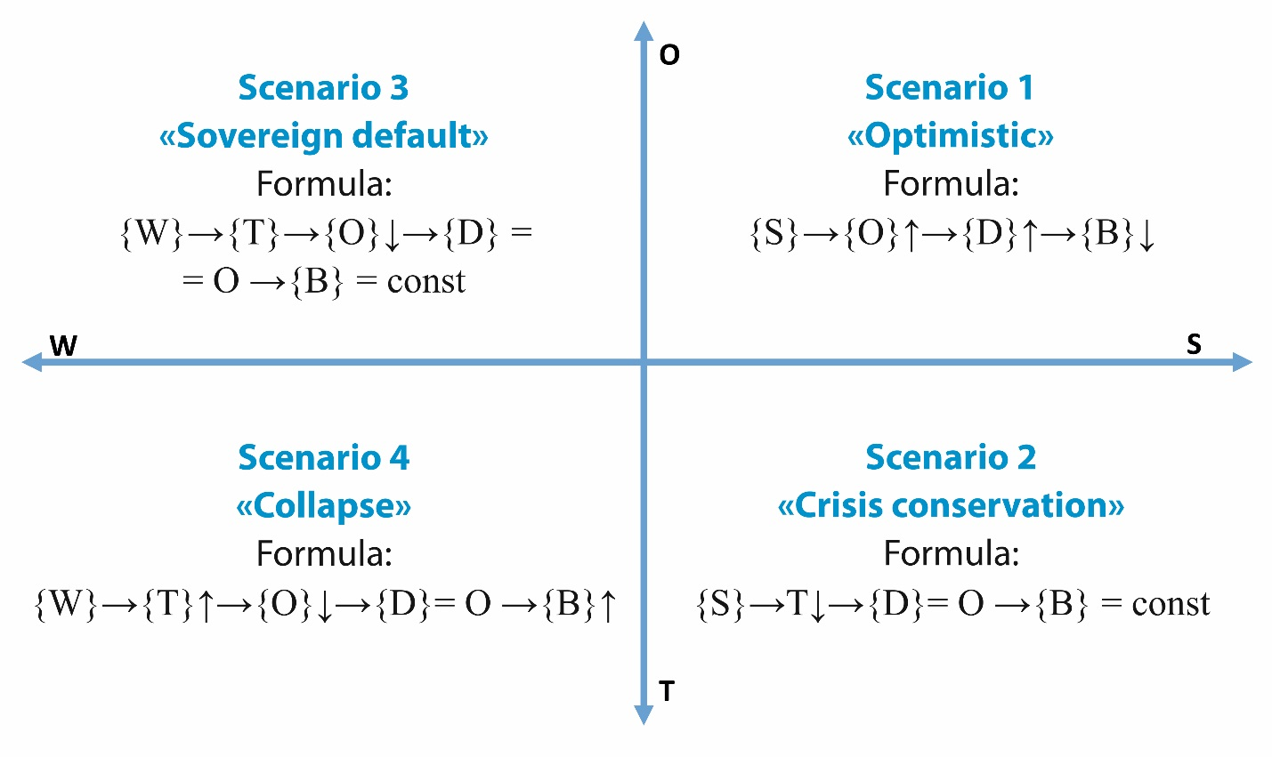
Fig. 2. Ukrainian economy fate model for mid-term period

Scenario 1 “Optimistic” can unfold if the multitude of strengths {S} consolidates with opportunities {O}, while the economic drivers {D} activate, and critical factors {B} that put brakes on economy and society are minimized.
Scenario 2 “Crisis conservation”, where the multitude of strengths {S} partially reduces the probability of threats {T}. Economy drivers {D} are not activated (except for partial activation of agricultural complex and ICT sector), braking factors {B} are not minimized.
Scenario 3 “Sovereign default” is possible should the inefficient policy of the national leaders continue. In this case, the multitude of economy weaknesses {W} marginally impairs the opportunities {O}, economy drivers {D}, are not activated, braking factors {B} are not minimized, and the pre-existing state of technical default effectively cuts off political and financial support of the country.
Scenario 4 “Collapse”. In this scenario the multitude of economy weaknesses {W} marginally impairs the opportunities {O}, and provokes the realization of multiple treats {T}, economy drivers {D} are not activated, braking factors {B} are increased.
Ukrainian economy fate model for long-term period also include 4 scenarios (please refer to fig.3) (Zgurovsky, 2015: p. 126):
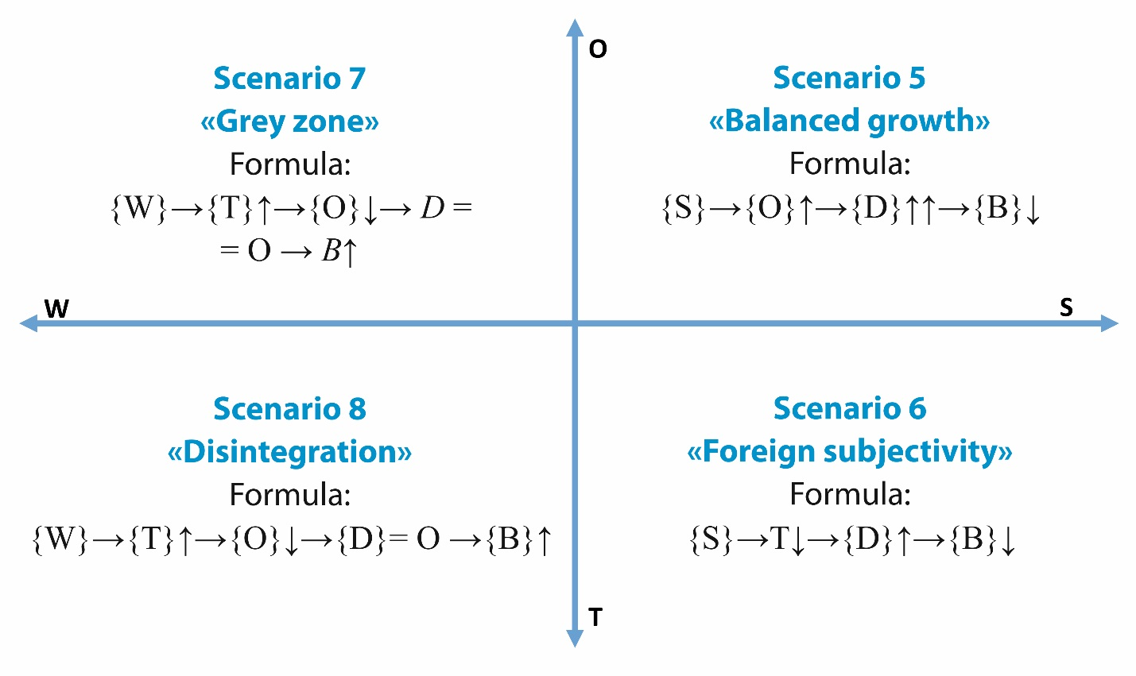
Fig. 3. Ukrainian economy fate model for long-term period

Scenario 5. “Balanced growth” suggests that the strengths {S} marginally improve the economy opportunities {O}, economy drives {D} are dynamically improved, the braking factors {B} are minimized. Under these circumstances, Ukrainian economy becomes self-sufficient.
Scenario 6. “Foreign subjectivity” can result from the realization of scenario 2 “Crisis conservation”. This scenario is likely to happened if the multitude of strengths {S} partially reduces the probability of threats {T}, economy drivers {D} remain inactive, and braking factors {B} are not minimized.
Scenario 7 “Grey zone”. This scenario can happen as a result of pessimistic conclusions to scenarios 2 or 3. The multitude of economy weaknesses {W} continues to impair the opportunities {O}, economy drivers {D} are not activated, braking factors “B” are increased, while the previous lead to further degradation of economy.
Scenario 8 “Disintegration”. This scenario can happen as a result of pessimistic conclusions to scenarios 3 or 4. The multitude of economy weaknesses {W} increases the threats {T} and impairs the opportunities {O}. Economy drivers {D} are not activated, braking factors {B} are increased, while the pre-existing condition of sovereign default or collapse renders the state incapable of performing its functions both at home and abroad.
Conclusions and recommendations for further research. The analysis of two Foresight researches conducted in Ukraine proves that the country is in need of establishing the unified state policy regulating the Foresight procedure. As of now, there is not unified national approach to Foresight research, no methodical continuity when it comes to conducting it, and, most importantly, there is no practice of using the research results in management.
There is no denying that institutionalization of Foresight research in the context of Ukrainian science and Foresight integration into Ukrainian management practice are anything but simple. The lack of culture in Ukraine when it comes to forecasting social changes is evident. This is attested by the practice of implementing social innovations and reforms in Ukraine. The reforms are performed without any scientific rationale that would prove their relevance and economic efficiency, thus turning out to by chaotic or even antisocial. Under the current circumstances the only option is to abandon the existing Ukrainian model and implement the practices used in developed countries, where financing for any innovation or industry is preceded by Foresight research.
As can be seen from the above, Ukraine is in pressing need of developing the unified Foresight research model that would provide the national decision makers with the tool of generating industry development scenarios, and would provide for making highly accurate forecasts due to the option of permanent forecast correction, which is largely important for improving the national export potential.

1. Definition of government from the Cambridge Advanced Learner’s Dictionary & Thesaurus Dictionary, http://dictionary.cambridge. org/dictionary/english/government. 2. Foresight of the Economy of Ukraine: medium-term (2015–2020) and long-term (2020–2030) time horizons / Research Project Manager Academician of National Academy of Sciences of Ukraine M. Z. Zgurovsky, Kyiv: NTUU «KPI», 2015, 136 p., Access: http://ied.kpi.ua/wp-content/uploads/2015/10/Foresight-2015.pdf. 3. Kotler, P., Armstrong, G. Principles of marketing, 14th Edition (Global Edition), Prentice Hall, 2012, 744 p.

